All-American Dashboard - Community Service
The Virginia Community Service Online Reporting tool is now feeding information to the National All-American Dashboard on a nightly basis. This document shows the steps to see the information on the All-American Dashboard and to see the percentage of increase/decrease from last year. This year’s All-American program requires a 10% increase from last year.
- Go to vfw.org and login with your account and password. On the first page, scroll down to Membership Quick Links and click All-American Dashboard
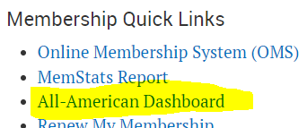
- Click Access the All-American Dashboard
- By default, your Post should be displayed. Hover over Community Service and you should see the totals for last year, this year, and the percentage of increase or decrease. 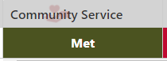 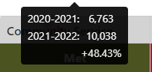

Follow these steps to see further details:
- At the top right, click KPI Tools
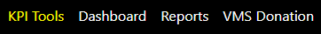
- Choose your District, then your Post 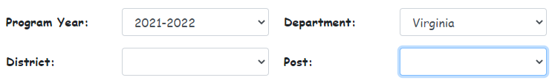
- Scroll down and you should see a block for Community Service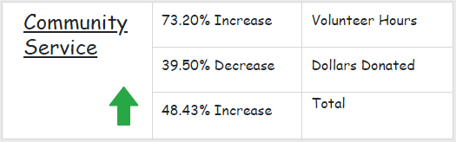

Another method to see further details
- Scroll back up to the top and click Community Service 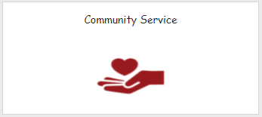
- Click on your District in the list 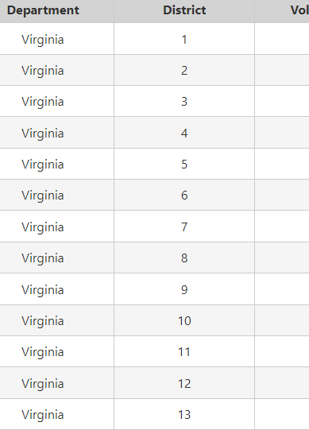
- You should then see the numbers for each Post within the District

